Cancer Research Division
PhD STUDENT COMMITTEE REPORT
STUDENT NAME: Peter Donnelly
MEETING DATE: 2 Dec 2019 | VENUE: PMCC Meeting Room 11.214
COMMITTEE: Student Committee 4
SUPERVISORS: Dr Ken Doig and Dr Thomas Conway
MENTOR: Dr Huiling Xu
LENGTH OF CANDIDATURE TO DATE: 8 months
PROJECT TITLE: ‘Improving Classification of T-Cell Lymphomas By Applying Machine Learning to Heterogeneous Data Types’
COMMITTEE MEMBERS PRESENT (TBC):
Chair: Prof David Bowtell, Co-Chair: Dr David Goode, Dr Carleen Cullinane,
Dr Luc Furic, Dr Omer Gilan, Dr Rae Farnsworth

For the 1st (6 month) Committee review meeting
  - Provide key background information (and references as appropriate) that has led to the definition of your project’s aims.
The idea for the project came from a discussion between Dr Piers Blombery and Dr Ken Doig.
The logic underpinning the project is as follows:
- Pathologists find it challenging to classify some Lymphoma subtypes; Peripheral T-Cell Lymphoma (PTCL) as a particular example. Inter- and Intra-pathologist variability can be quite high for PTCL.
- Machine Learning has been making explosive progress since about 2010. Deep Learning Networks have show great early promise in classifying cancers from histopathology images and are on the cusp of becoming clinically relevant, however ML efforts in diagnostic pathology still mostly focus on low hanging fruit: easier to classify cancers; and opportunistically where good labelled data for use in training happens to be available.
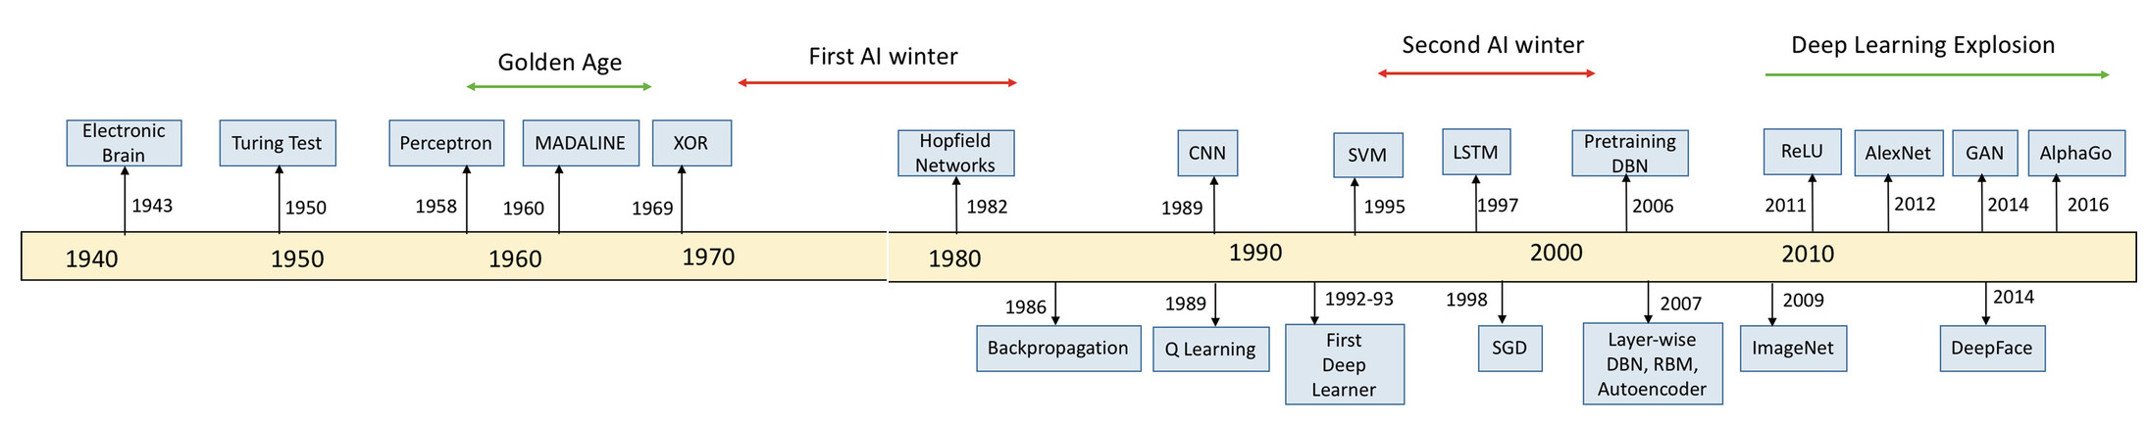
Image: Kamath U., Liu J., Whitaker J. (2019) Introduction. In: Deep Learning for NLP and Speech Recognition. Springer.

- Techniques exist, including and especially so called ‘Multi-Modal Learning’; which allow simultaneous learning from more than one data type (e.g. Image data + gene expression data). The primary hypothesis of this project is that such techniques might beneficially be applied to the problem of classifying otherwise difficult to resolve Lymphoma sub-types.
Assumptions surrounding the project are as follows:
- Gene expression testing (Microarrays, RNASeq, Nanostring) will ultimately become routine clinical tests for all cancer patients. Only the timing is unknown.
- Ultimately, purely manual analysis of bio-specimens will not be sustainable due to the enormous volumes of images and data which being generated
- Publicly accessible labelled WSI and genomic datasets have passed the threshold of viability for Machine Learning, and will only become more extensive and useful with time.
Key Motivating Papers:
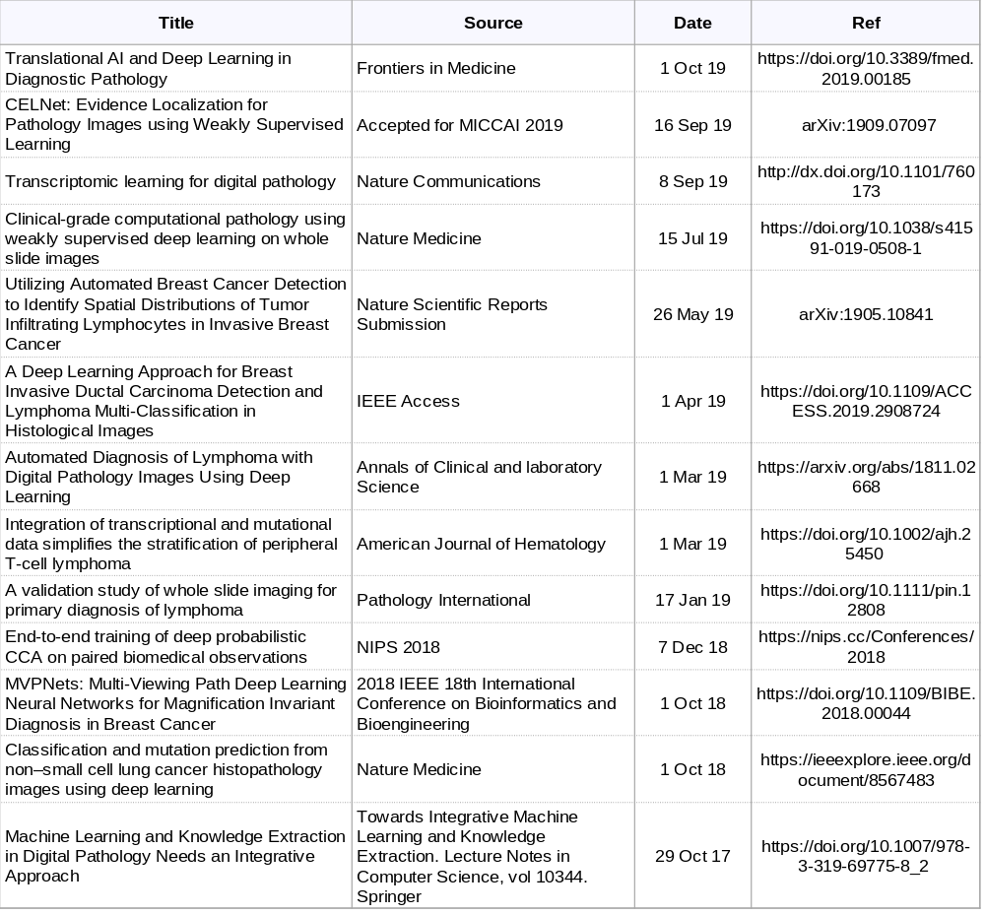

  - Are the topic and aims now well defined? What are the aims?

Yes.

Aim1: Establish a baseline toolchain using mainstream machine learning models and use to test the hypothesis on ‘easy’ data, viz: publicly available autopsy and B-Cell lymphoma data from The Cancer Genome Atlas (TCGA) and The Genotype-Tissue Expression (GTEx) project

Aim2: Develop and validate and test a multi-modal learning network that is able to classify ‘difficult’ data; viz: PMCC B-Cell and T-Cell Lymphoma samples.

Aim3: Clinical Translation: Convert the learning network resulting from Aim 2 into a useful, usable and clinically relevant support tool for Curators and Pathologists.

  - Are the appropriate methods for your project established?

Yes. The primary method of addressing the studies aim(s) will be through the use, adaptation and customization of contemporary machine learning architectures, algorithms and techniques in combination with publicly available databases such as TCGA, Camelyon and GTE which hold whole slide image (WSI) data and gene expression data.

  - Do you have a good understanding of the literature relevant to your project?

Yes.

To date I have:
- reviewed a large number of papers relevant to this PhD and constructed structured summaries of the most useful and relevant of those papers.
- conducted ‘deep dives’ into relevant contemporary ML algorithms, models, and techniques.
- experimented with existing domain-relevant ML applications & datasets, including ML applications which analyse cancer pathology samples.

  - How good are you at finding help (technical or academic) when your project calls for it?

I have a number of relationships with the Peter Mac researchers as well as many colleagues in the software engineering industry whose expertise I am able to draw on. I have contacted and received replies from authors of papers relevant to my project.

  - Have any problems been encountered which need to be resolved?

Not at this stage.

  - Do you have any plans for publications or conference presentations related to your project ? (present a plan if you think it would be helpful)

Yes, but I am not in a position yet to be specific.

Possible first author papers:

- Review Paper: Extracting Common Signals from Heterogeneous Biological Specimen Data
- Looking for Common Signals in Heterogeneous Cancer Specimen Data
- A Multi-model Deep Learning Model for Classifying Lymphomas

  - Are there any issues you wish to discuss with your committee?

No, however it is an ambitious project for which success is far from guaranteed, so I welcome any guidance that the committee may be able to provide.

  - Are the short and long term experiments clearly mapped out?

Yes.
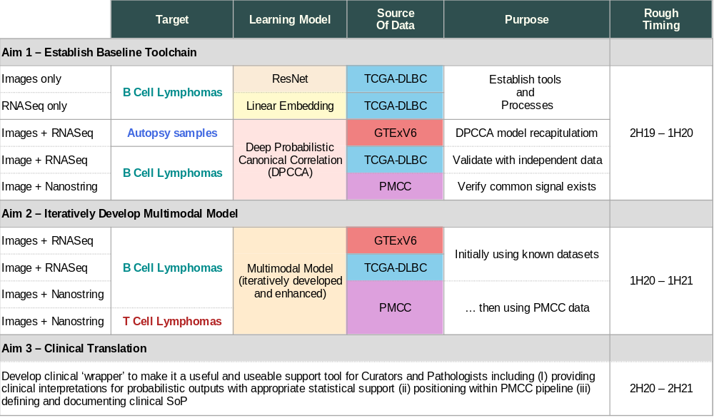

  - Do you have a time line to show?

Yes. See 9 above

  - Overall, do you think you are on track with your project?

Yes.

  - Committee Comments/Report (to be completed by Mentor after the meeting):

Research Training in past year

Attach a summary sheet for the research training activities highlighting the activities you participated in since commencing, including details of any of the following:
- Induction and Orientation program
- Specialist laboratory skills training
- Hub, Lab meetings and Journal clubs
- Seminar and workshop programs
- Annual Student Retreat
- Topics in Cancer program
- Research Seminar program
- Research lunches attended
- Research Governance program
- Research reporting (Presentations, written reports submitted etc)
- Technical seminars

